DOKUMENTASI LEMBAR KERJA
SUPERLAB – ASJ DEBIAN 10
Nama : M. Danu Hidayat
NIS : 12410503
Rombel : TJKT XI-2

- Install Server Debian 10
- Hasil Konfigurasi
No | Konfigurasi | Screenshot Hasil Konfigurasi
1 | Guest OS | 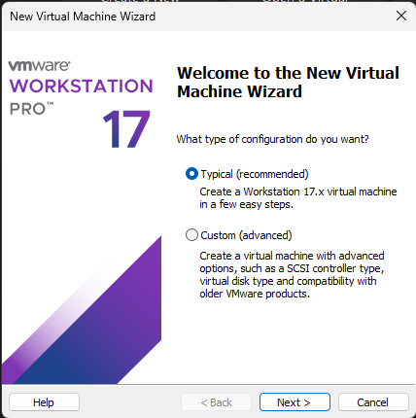
2 | Virtual Machnie Name | 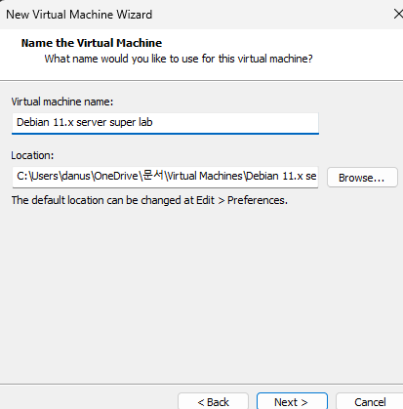
3 | Disk Space | 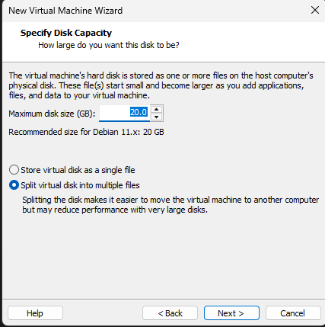
4 | Memory | 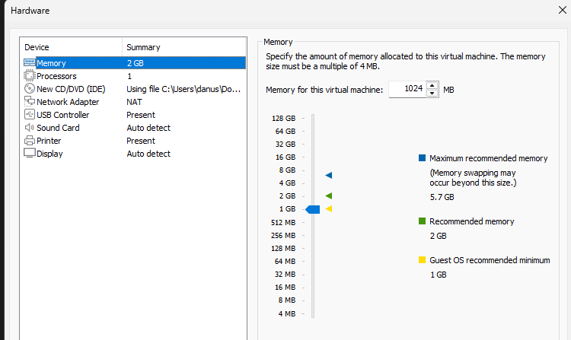
5 | Network Adapter | 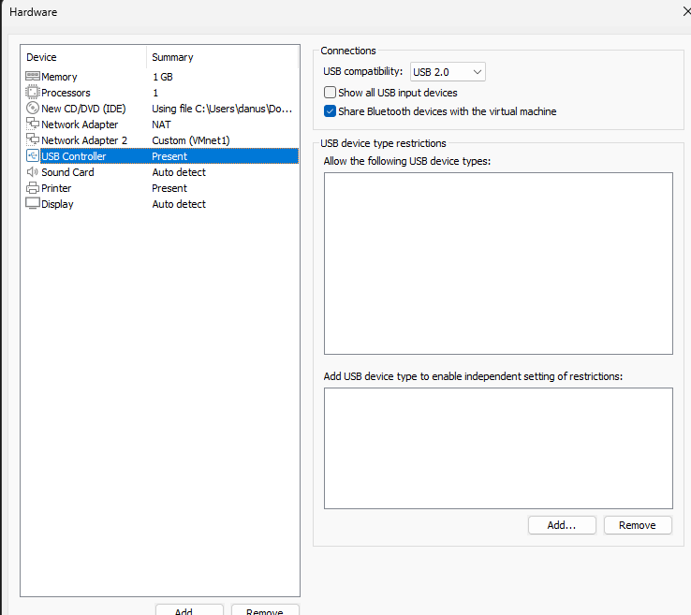
6 | Username | 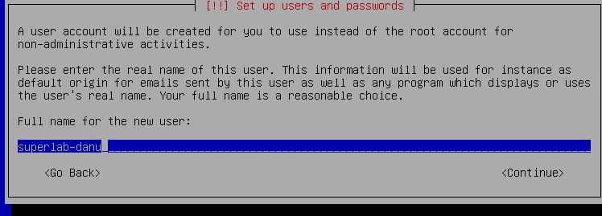
7 | Password | 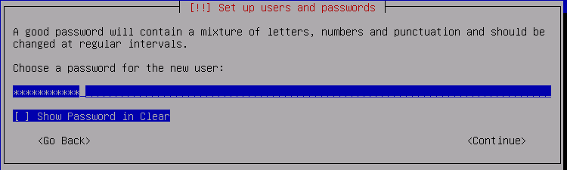
8 | Partisi | 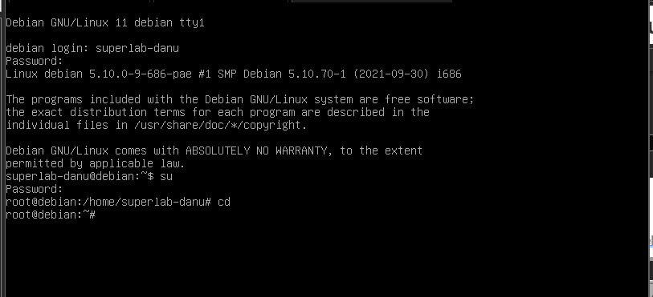
9 | IP Address | 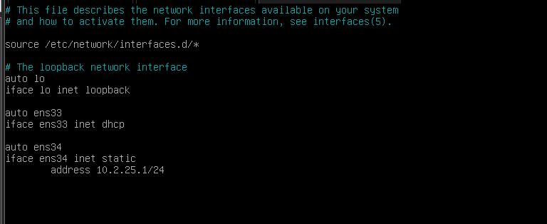
10 | Repository Lokal | 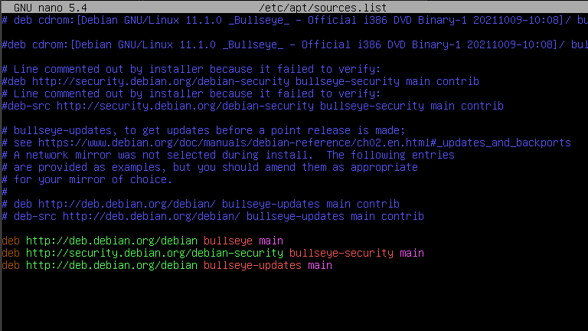
11 | Update Repository | 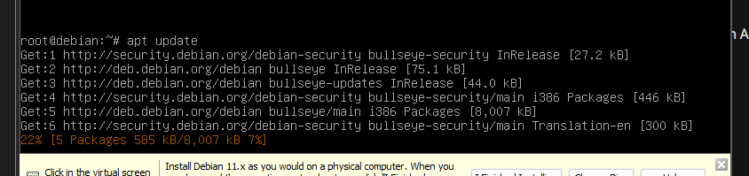

- SSH Server
- Hasil Konfigurasi
No | Konfigurasi | Screenshot Hasil Ujicoba
1 | Update package | 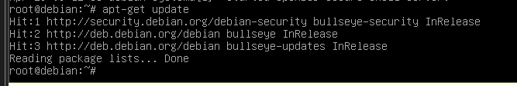
2 | Install SSH | 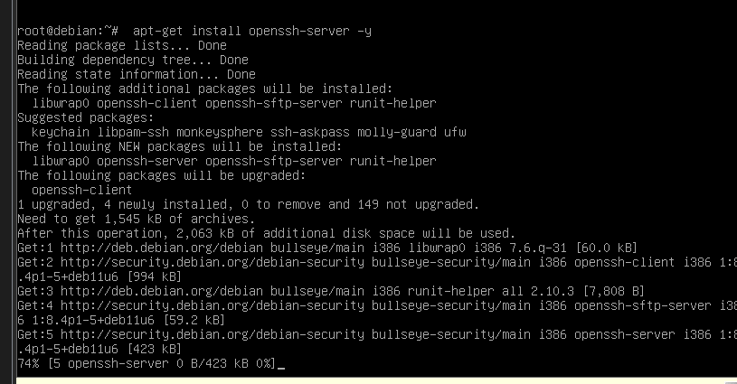
3 | Edit file sshd_conf | 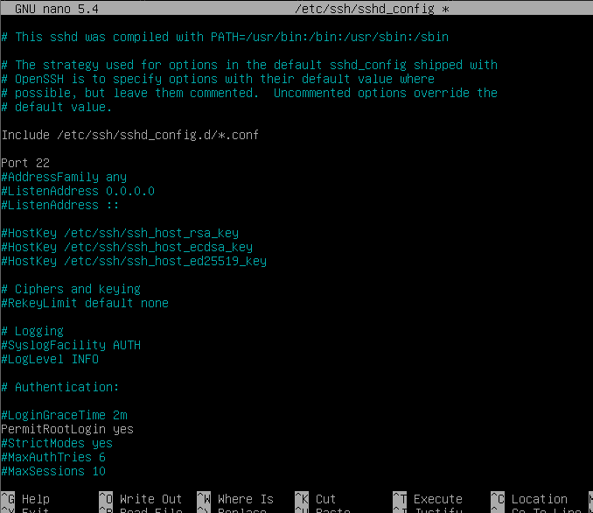
4 | Restart service SSH | 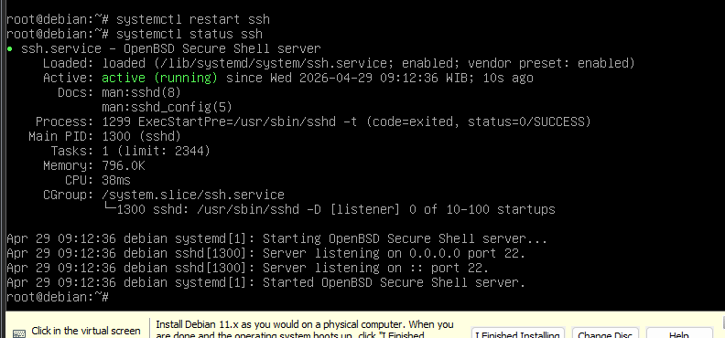
5 | Konfig IP Address Client | 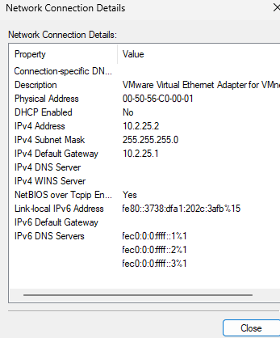
6 | Snapshoot | 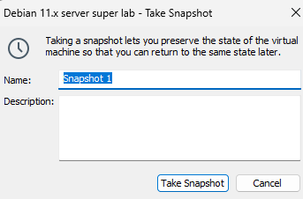

- Hasil Ujicoba
No | Uji Coba | Screenshot Hasil Ujicoba
1 | Ping ke IP Server | 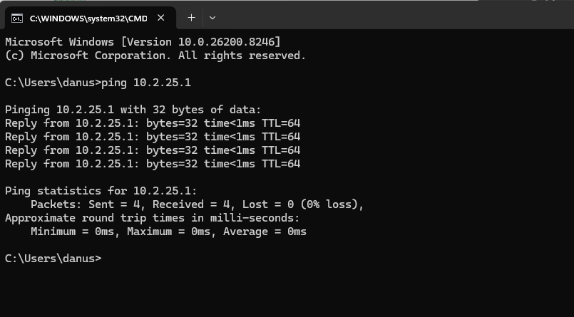
2 | Konek SSH menggunakan Putty | 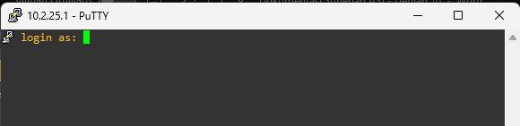
3 | Login sebagai root | 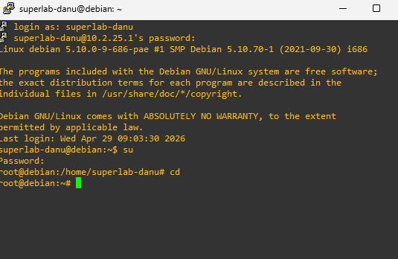

- DHCP Server
- Hasil Konfigurasi
No | Konfigurasi | Screenshot Hasil Ujicoba
1 | Snapshoot | 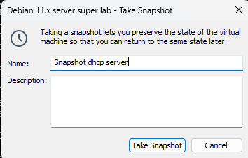
2 | Install DHCP Server | 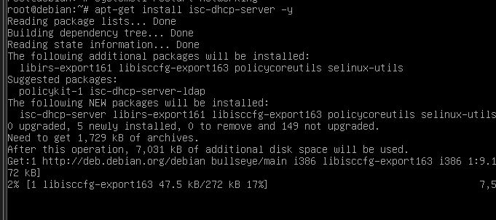
3 | Edit file dhcpd.conf | 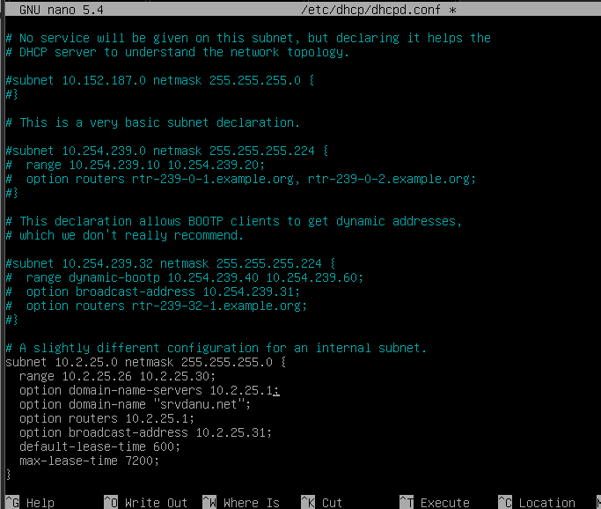
4 | Edit file default isc-dhcp-server | 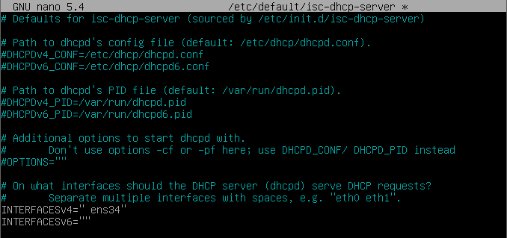
5 | Restart Service DHCP Server | 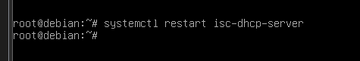
6 | Konfig IP DHCP disisi Client | 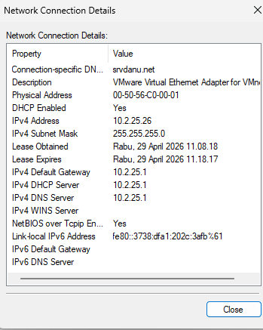

- Hasil Ujicoba
No | Uji Coba | Screenshot Hasil Ujicoba
1 | Cek IP di Interface Host-Only | 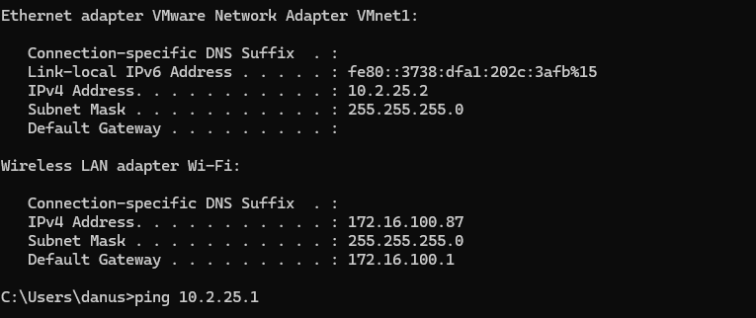
2 | Test Ping ke IP Server | 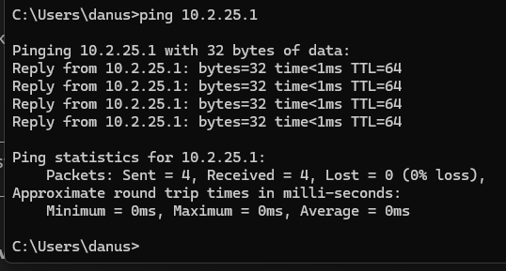

- DNS Server
- Hasil Konfigurasi
No | Konfigurasi | Screenshot Hasil Ujicoba
1 | Snapshoot | 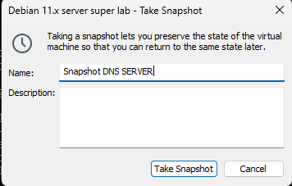
2 | Install DNS Server | 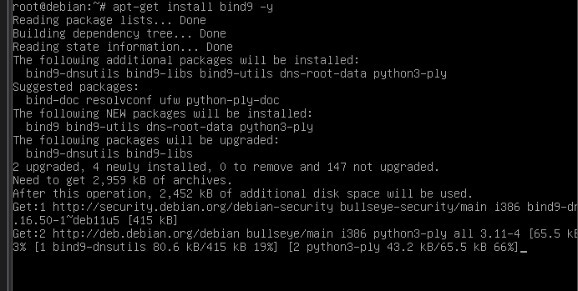
3 | Copy file Forward
4 | Copy file Reverse | 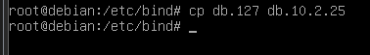
5 | Edit file Forward (db.domain) | 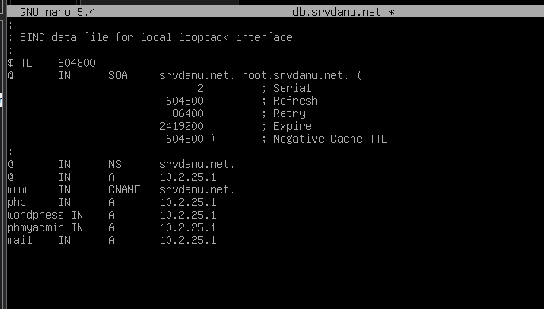
6 | Edit file Reverse (db.ipaddress) | 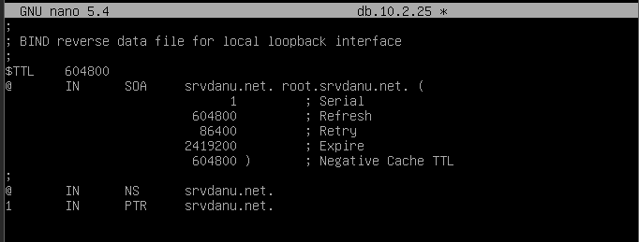
7 | Edit file conf.default-zones | 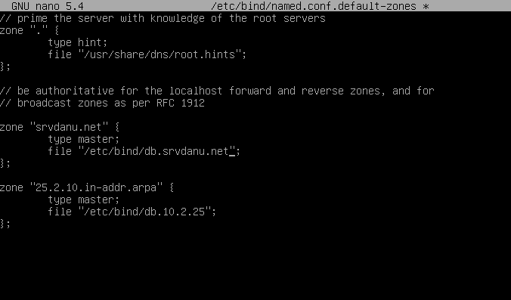
8 | Edit file resolv.conf | 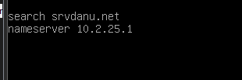
9 | Restart service DNS Server | 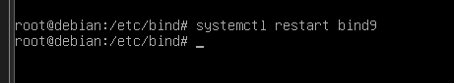
10 | nslookup menggunakan domain | 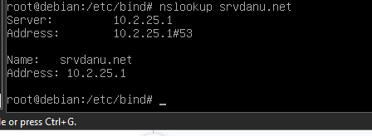
11 | nslookup menggunakan sub-domain | 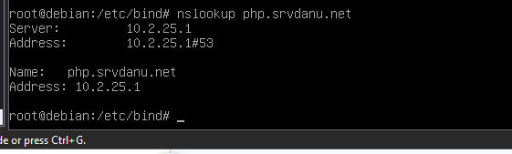
12 | nslookup menggunakan ip address | 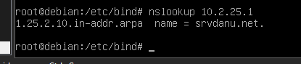

- Hasil Uji Coba
No | Uji Coba | Screenshot Hasil Ujicoba
1 | Cek IP di Interface Host-Only | 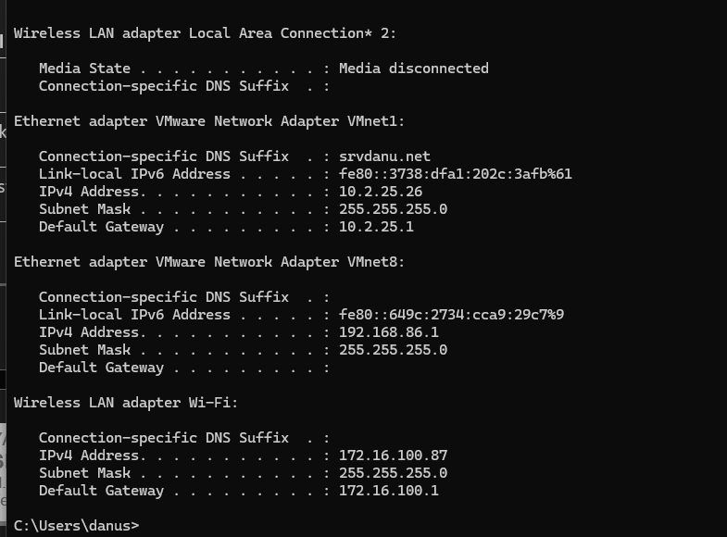
2 | Test ping ke ip address di cmd | 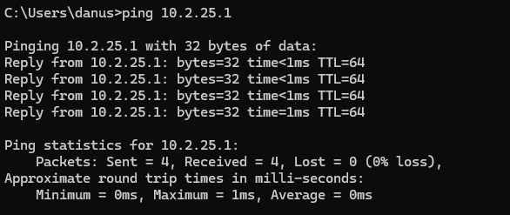
3 | Test ping ke domain di cmd | 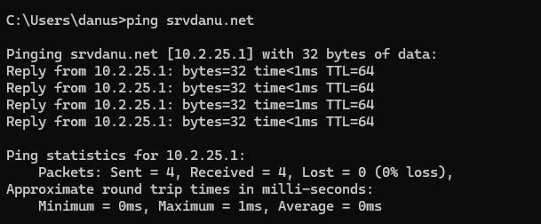
4 | Test ping ke subdomain di cmd | 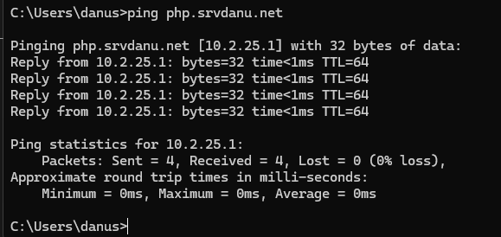
5 | nslookup ip address, domain dan subdomain di cmd | 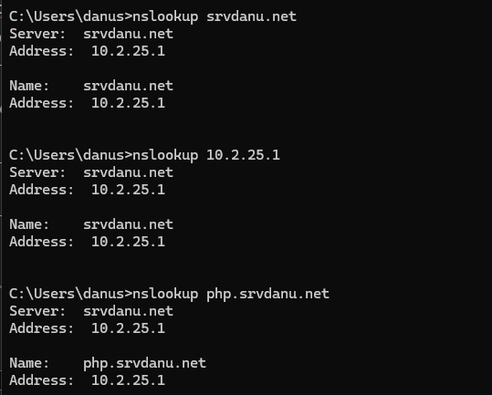

- FTP Server
- Hasil Konfigrasi
No | Konfigurasi | Screenshot Hasil Ujicoba
1 | Snapshoot | 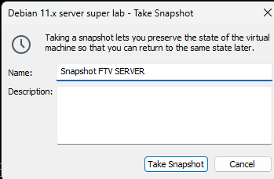
2 | Install FTP Server | 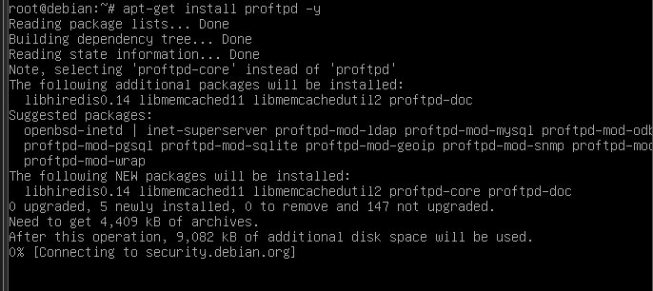
3 | Buat User Baru | 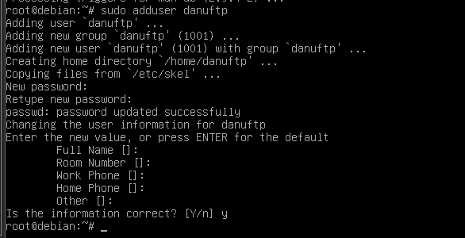
4 | Set Password User Baru | 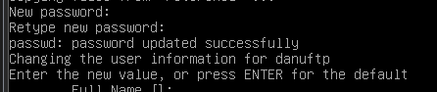
5 | Edit file proftpd.conf | 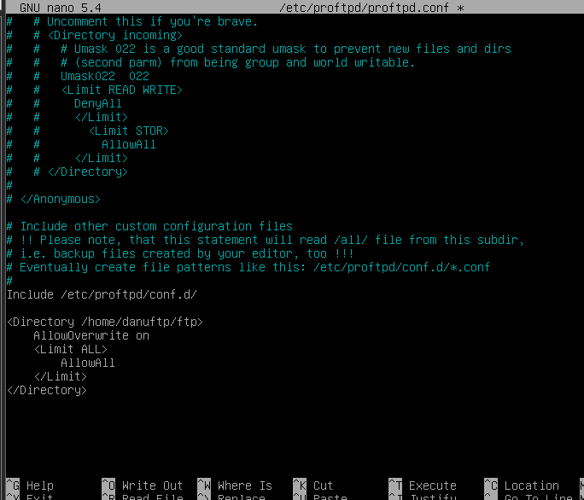
6 | Buat direktori ftp | 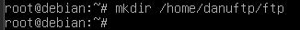
7 | Ubah hak akses direktoti ftp | 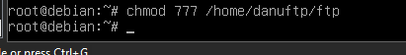
8 | Restart service FTP Server

- Hasil Ujicoba
No | Uji Coba | Screenshot Hasil Ujicoba
1 | Akses FTP Server (FileZilla) | 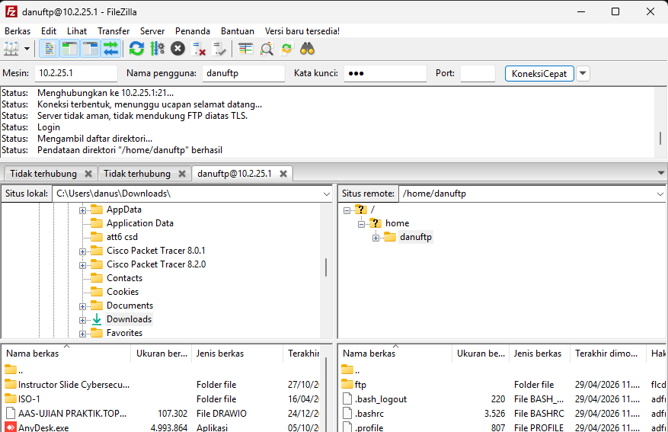
2 | File text (Notepad) | 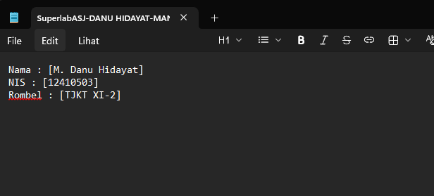
3 | Upload file text ke FTP Server | 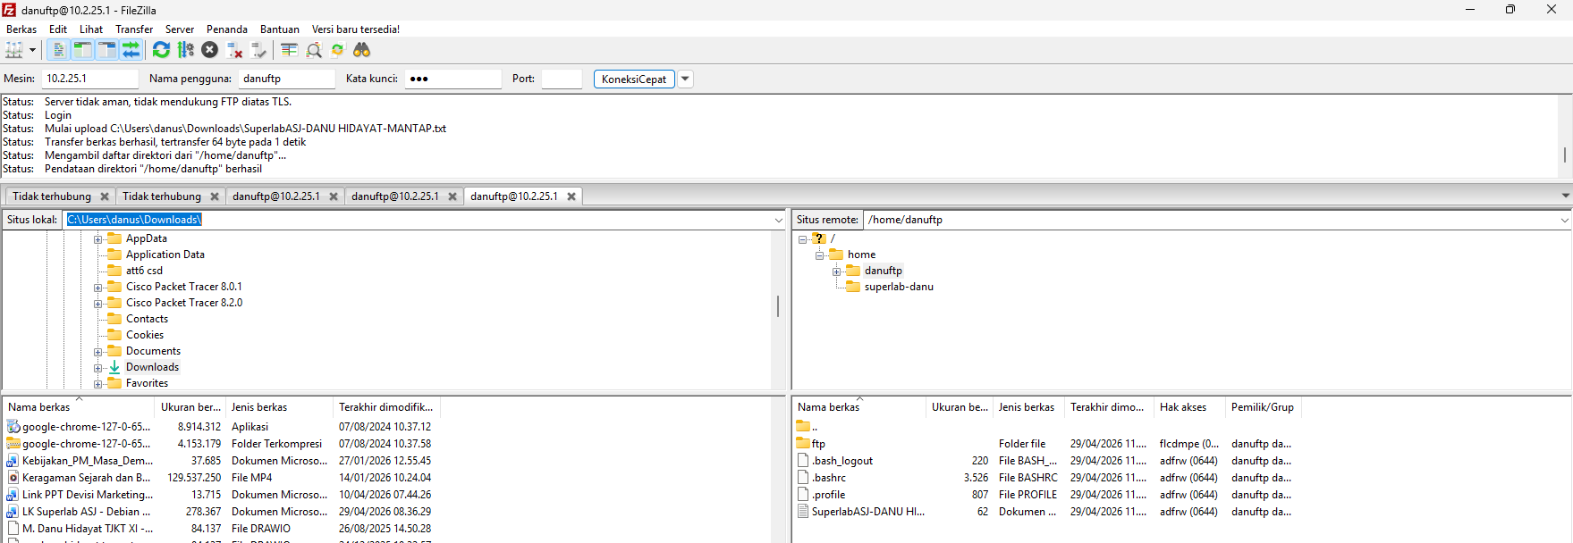
4 | Cek isi file text di sisi Server | 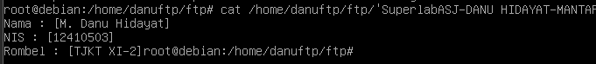

- Web Server dan Databases
- Web Statis (html dan php)
- Hasil Konfigurasi
No | Konfigurasi | Screenshot Hasil Ujicoba
1 | Snapshoot | 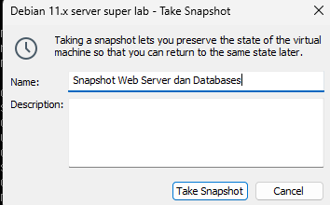
2 | Update package | 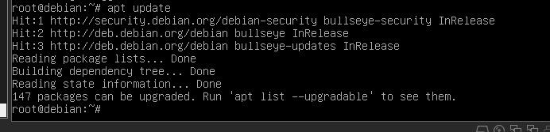
3 | Install Web Server | 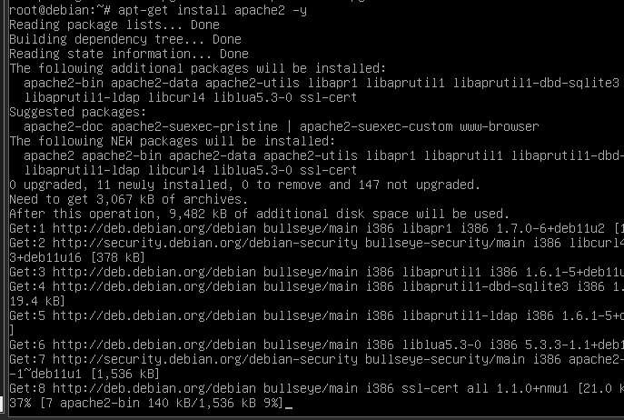
4 | Hapus file index.html | 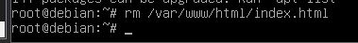
5 | Buat file index.html baru | 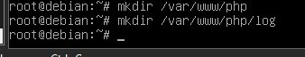
6 | Edit file index.html | 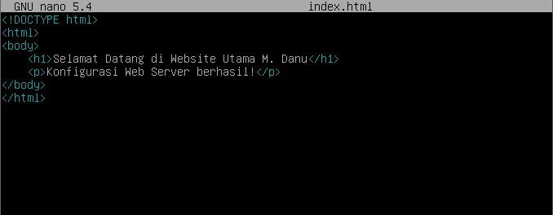
7 | nslookup subdomain php | 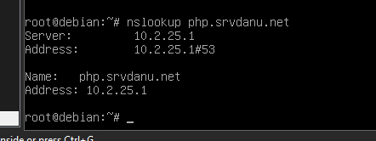
8 | Buat file DocumentRoot dan log php | 
9 | Ubah Permission | 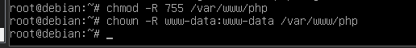
10 | Edit file index.php | 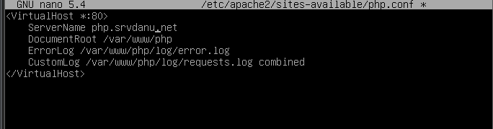
11 | Buat direktori virtualhost php | 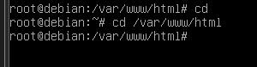
12 | Edit file php.conf | 
13 | Enable virtualhost php | 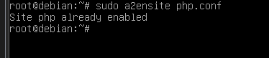
14 | Reload dan restart web server | 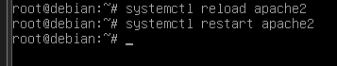

- Hasil Uji Coba
No | Uji Coba | Screenshot Hasil Ujicoba
1 | Cek IP Interface Host-Only | 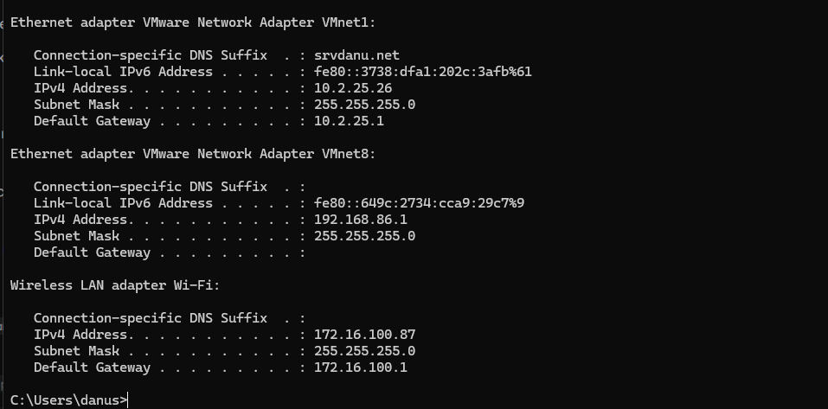
2 | Search website domain utama | 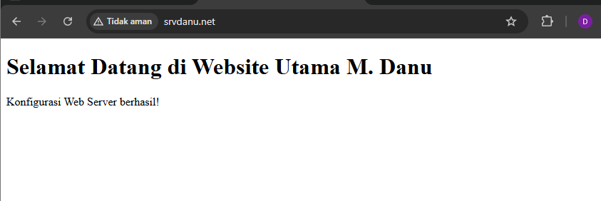
3 | Search website subdomai php | 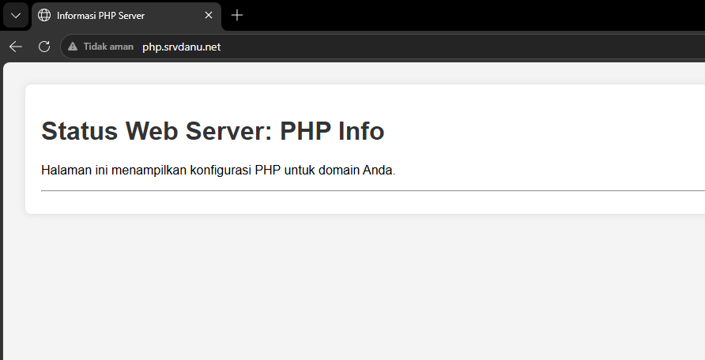

- WordPress
- Hasil Konfigurasi
No | Konfigurasi | Screenshot Hasil Ujicoba
1 | Snapshoot | 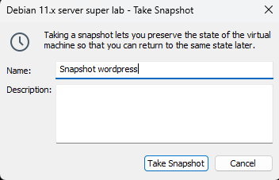
2 | Install Databases Server, PHP, dan Unzip | 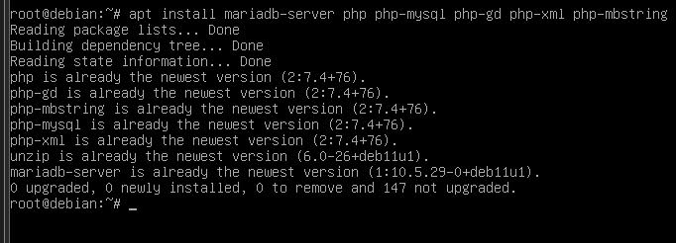
3 | nslookup subdomain wordpress | 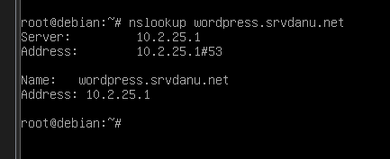
4 | Buat DocumentRoot dan log wordpress | 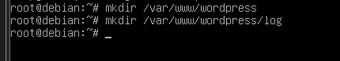
5 | Pindah ke direktori DocumentRoot wordpress | 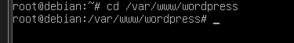
6 | Download installer wordpress | 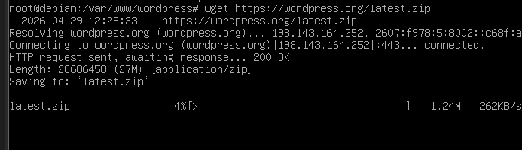
7 | Unzip file latest.zip
8 | Pindahkan file dari direktori wordpress | 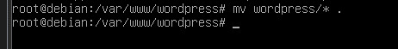
9 | Hapus direktori wordpress/ | 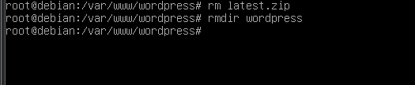
10 | Ubah owner dan permission DocumentRoot wordpress | 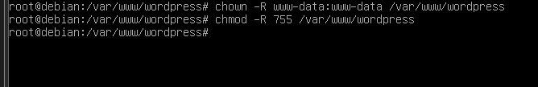
11 | Konfigurasi installation database (myql_secure_installation) | 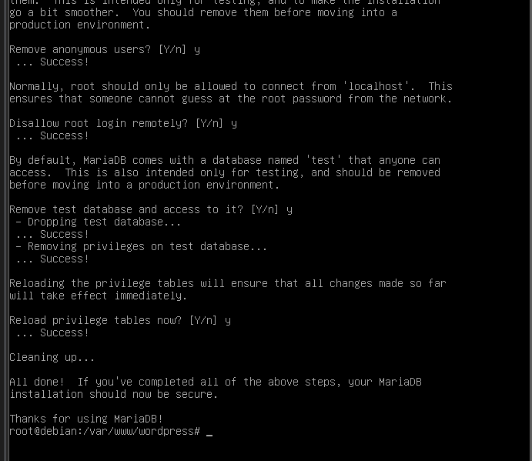
12 | Buat database dan user untuk wordpress | 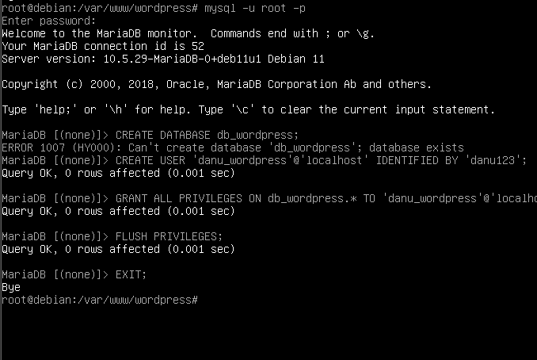
13 | Buat direktori virtualhost wordpress
14 | Edit file wordpress.conf | 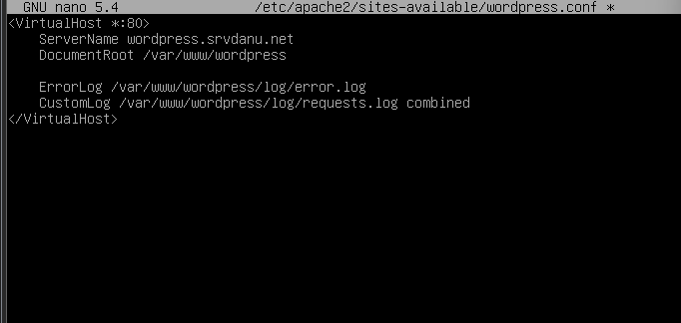
15 | Enable virtualhost wordpress.conf | 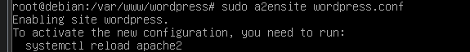
16 | Reload dan restart web server | 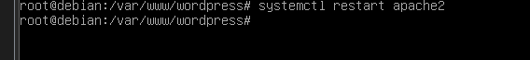

- Hasil Uji Coba
No | Uji Coba | Screenshot Hasil Ujicoba
1 | Akses website subdomain wordpress | 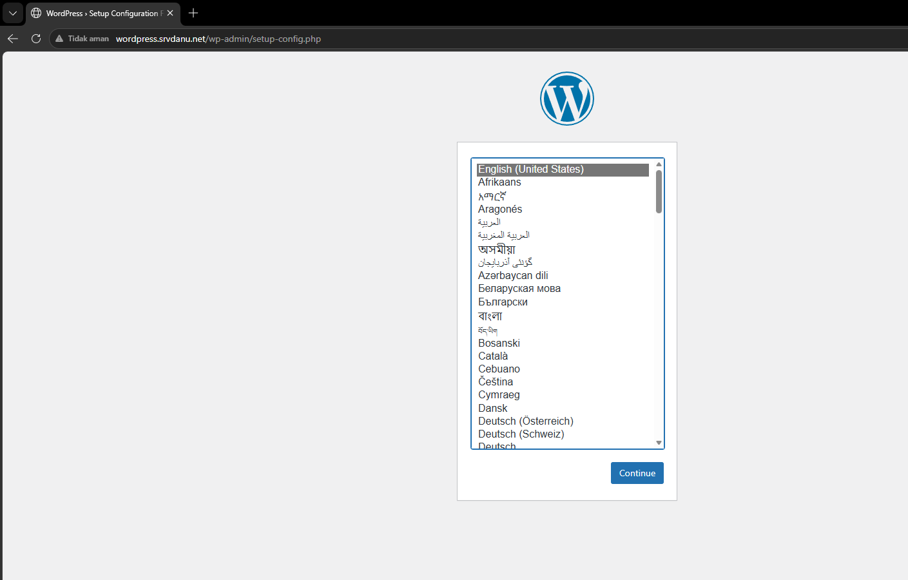
2 | Isi informasi databases connection | 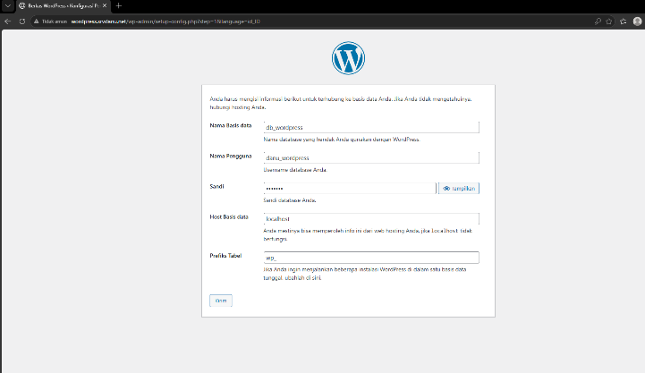
3 | Edit file wp-config.php | 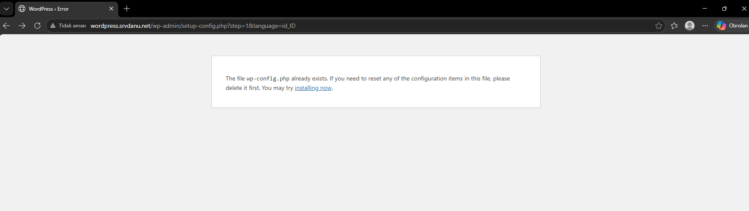
4 | Isi halaman informasi website | 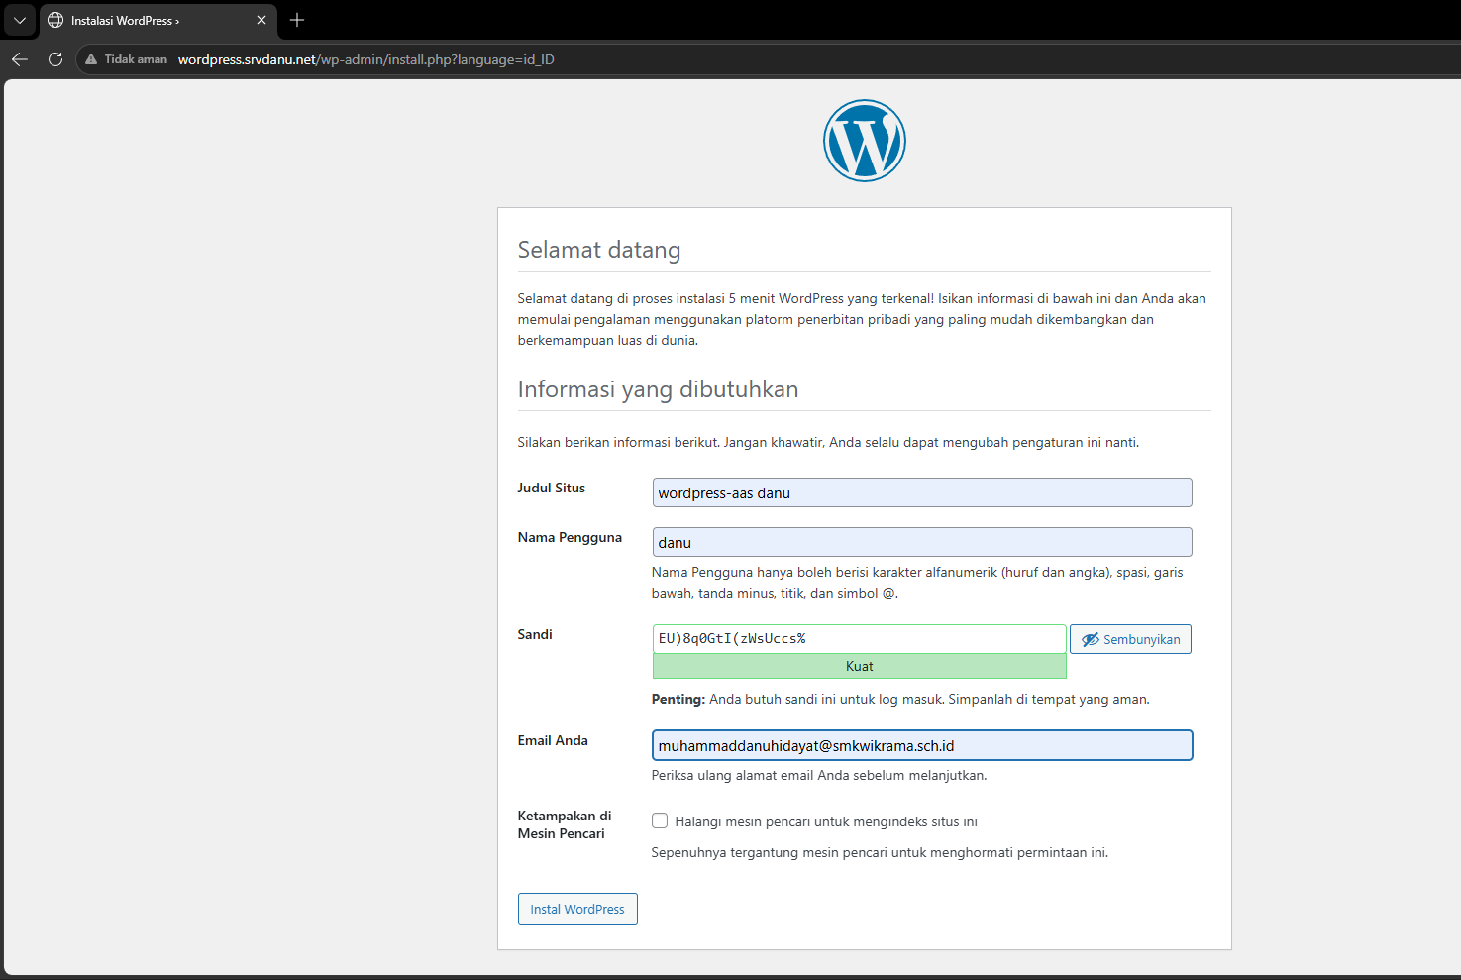
5 | Login wp-admin | 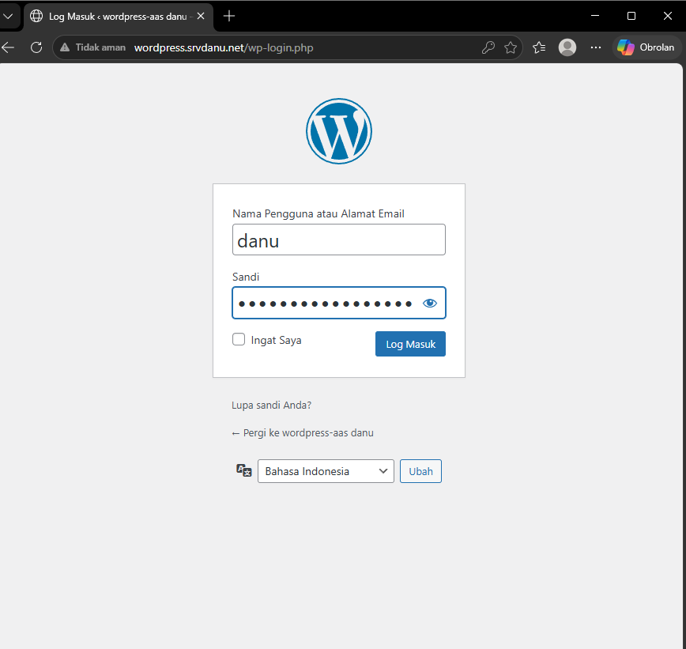
6 | Tampilan dashboard wp-admin | 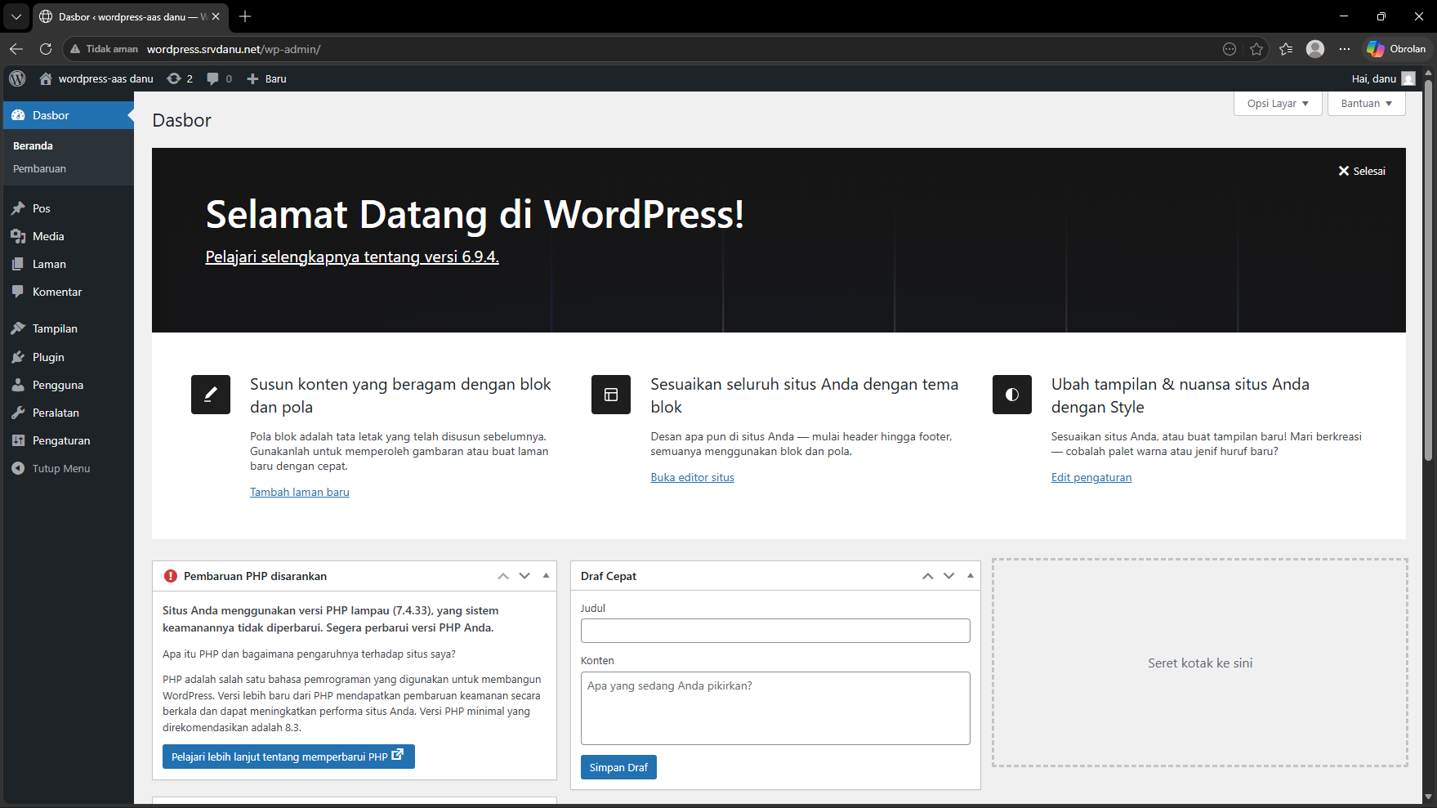
7 | Tampilan website wordpress | 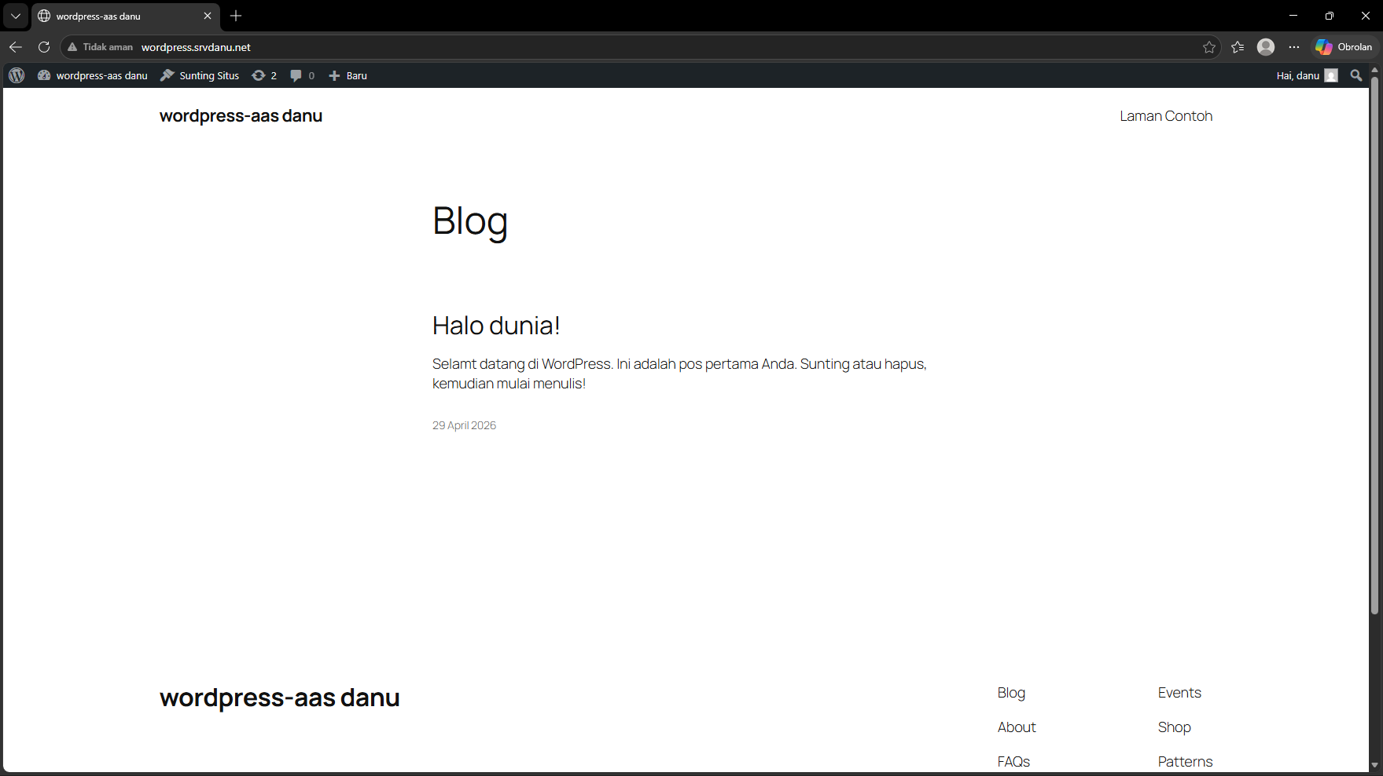

- phpMyAdmin
- Hasil Konfigurasi
No | Konfigurasi | Screenshot Hasil Ujicoba
1 | Snapshoot | 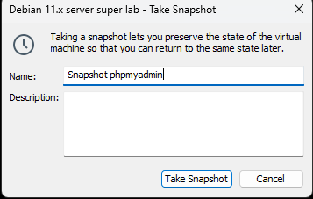
2 | Install depedency php di satukan dengan mariadb-client | 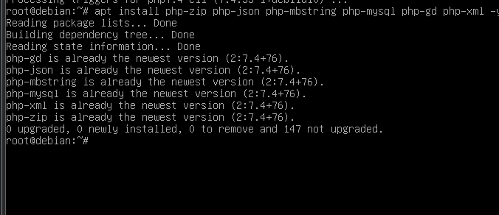
3 | Install mariadb-client disatukan dengan depedency | 
4 | Install gnupg disatukan dengan dependency dan mariadb client | 
5 | Buat DocumentRoot dan log phpmyadmin | 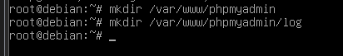
6 | Pindah ke DocumentRoot phpmyadmin | 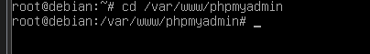
7 | Download Installer phpMyAdmin | 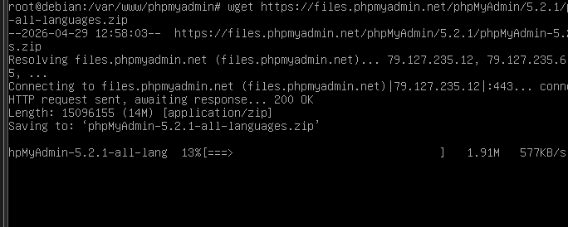
8 | Download digital signature file installer phpMyAdmin | 
9 | Cek installer dan digital signature | 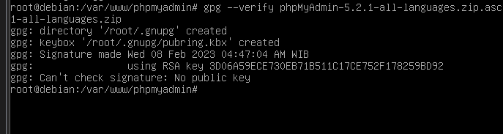
10 | Import keyring phpMyAdmin
11 | Unpack file installer phpMyAdmin
12 | Buat direktori virtualhost phpmyadmin | 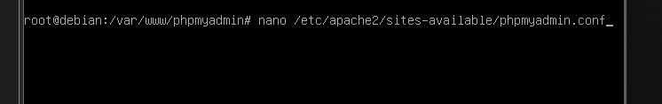
13 | Edit file phpmyadmin.conf | 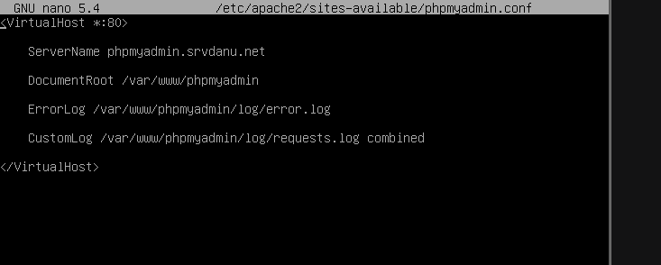
14 | Enable virtualhost phpmyadmin.conf | 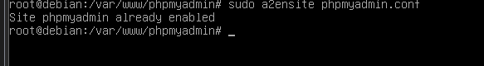
16 | Reload dan restart web server | 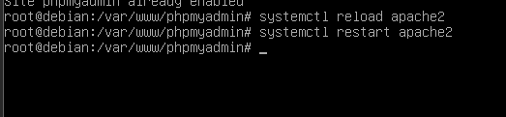
17 | Konfig CRUD – Silahkan di lanjut sendiri !!! | 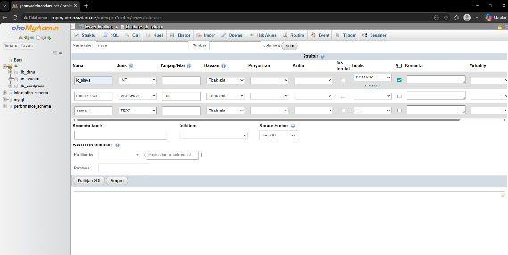

- Uji Coba
No | Uji Coba | Screenshot Hasil Ujicoba
1 | Cek IP Address interface Host-Only | 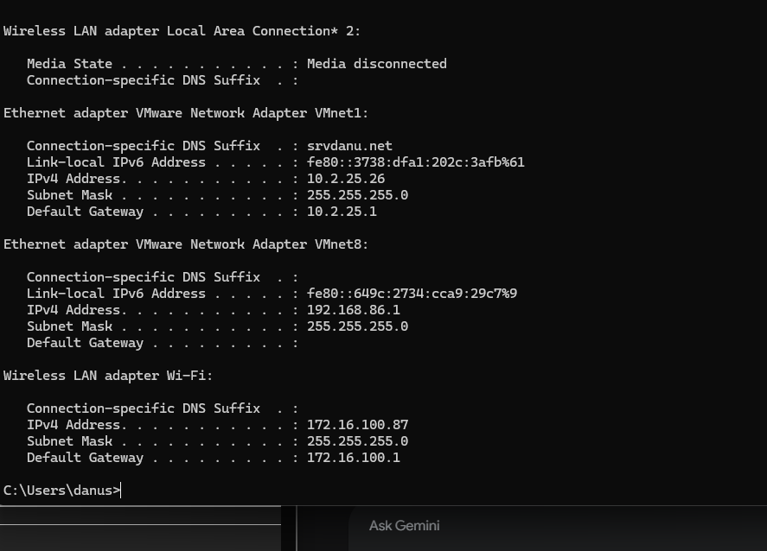
2 | Search website subdomain phpmyadmin | 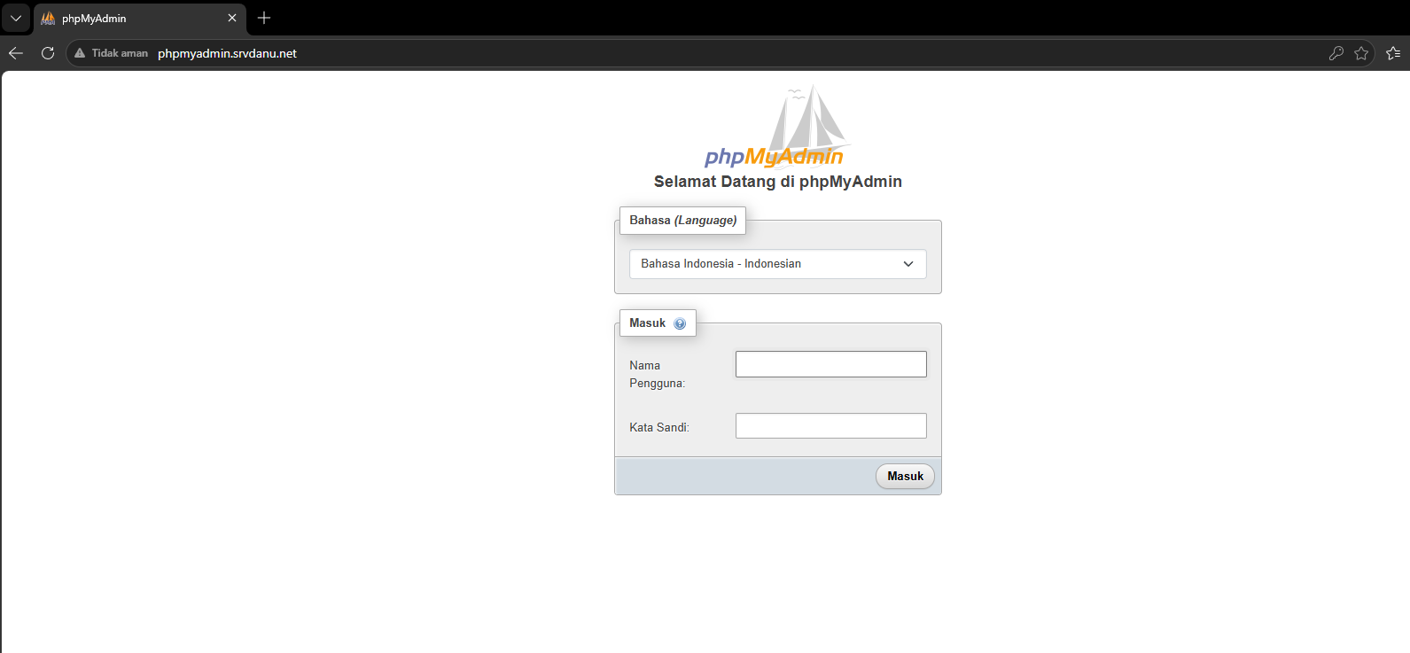
3 | Login menggunakan user root | 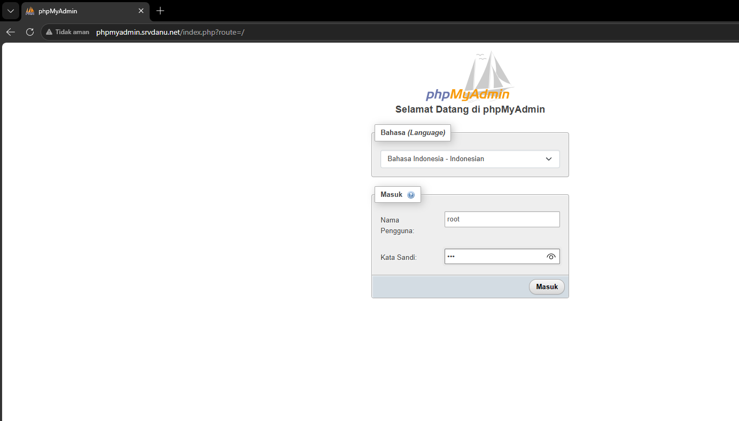
4 | Screenshoot tampilan Dashboard phpmyadmin | 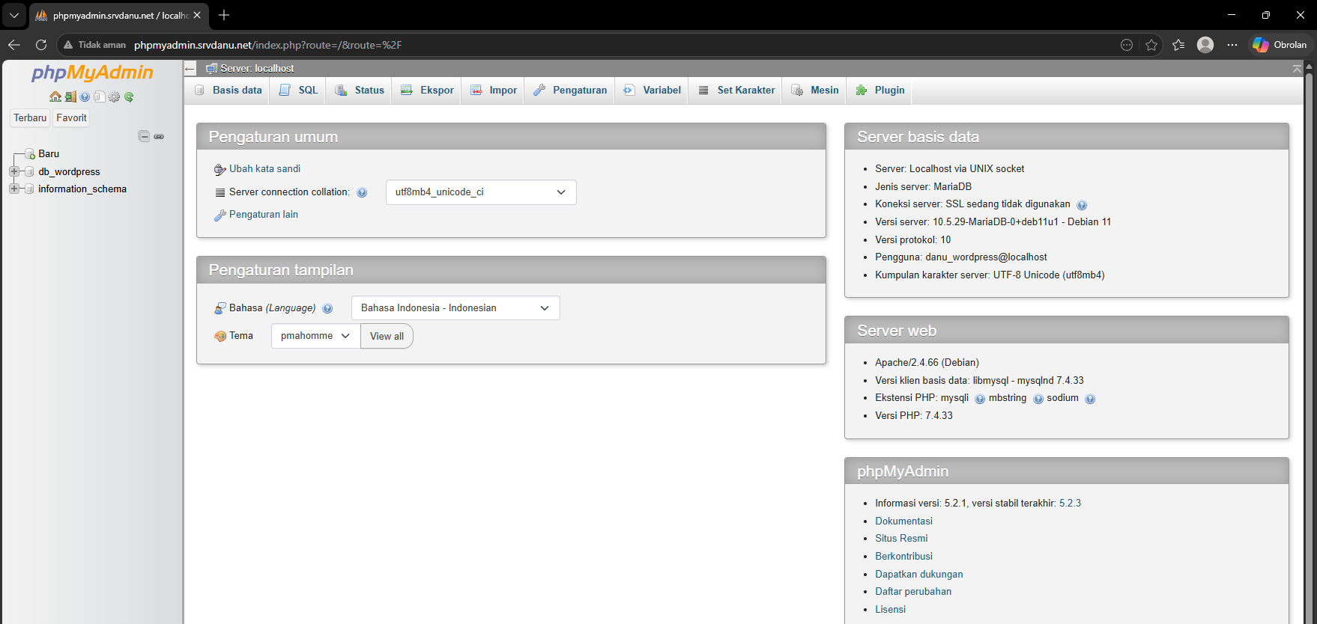
5 | Screenshoot tampilan website CRUD | 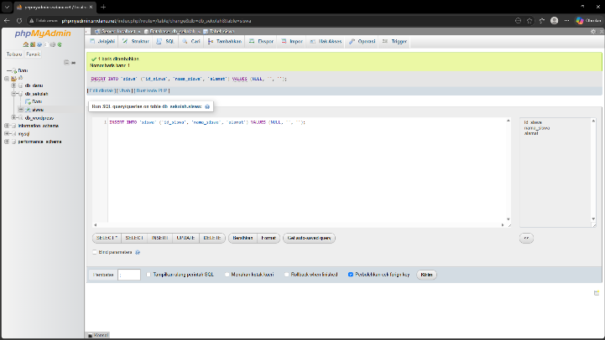
6 | Buat / tambah data melalui Web CRUD | 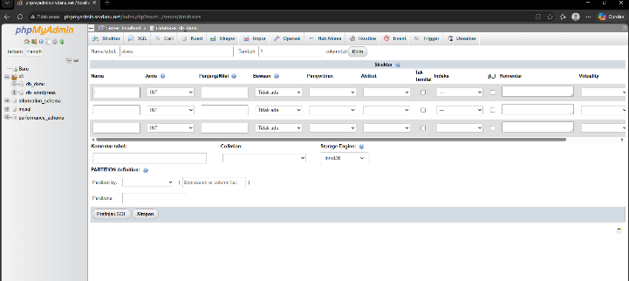
7 | Update data melalui Web CRUD | 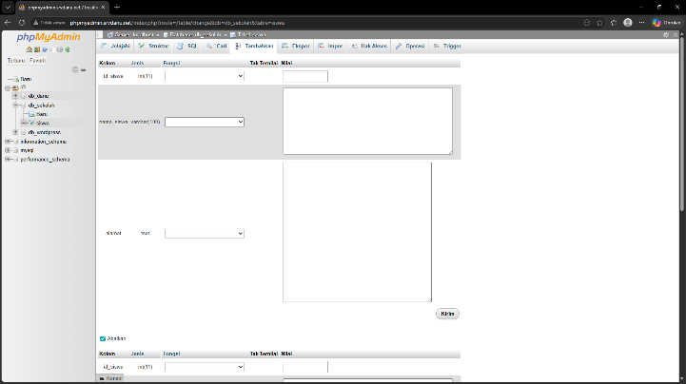
8 | Hapus data melalui Web CRUD | 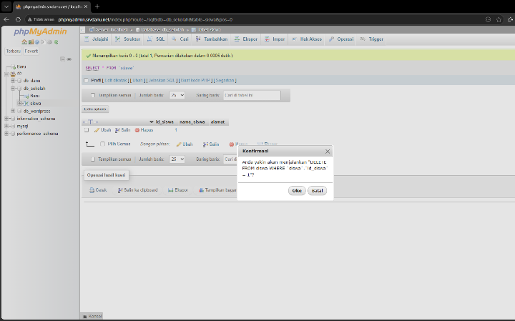

- Mail Server
- Hasil Konfigurasi
No | Konfigurasi | Screenshot Hasil Ujicoba
1 | Snapshoot | 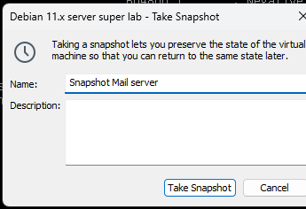
2 | Install postfix dan dovecot | 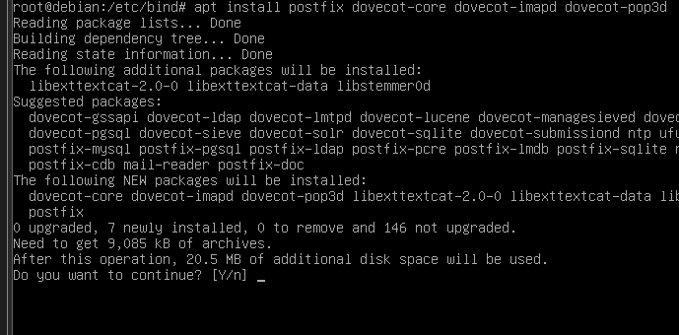
3 | Dpkg reconfigure postfix | 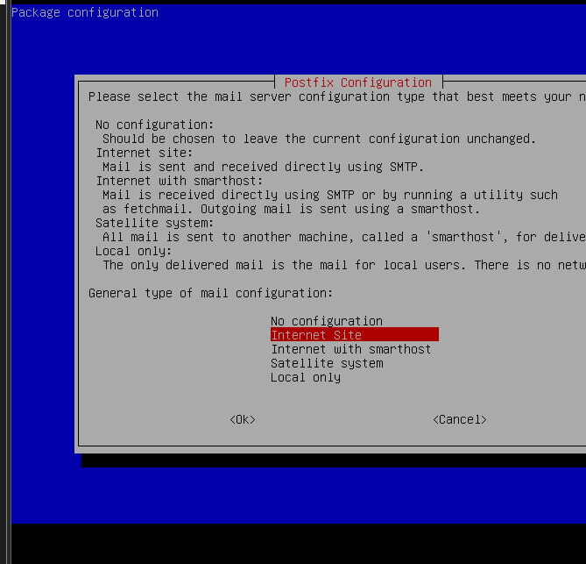
4 | Edit file main.cf | 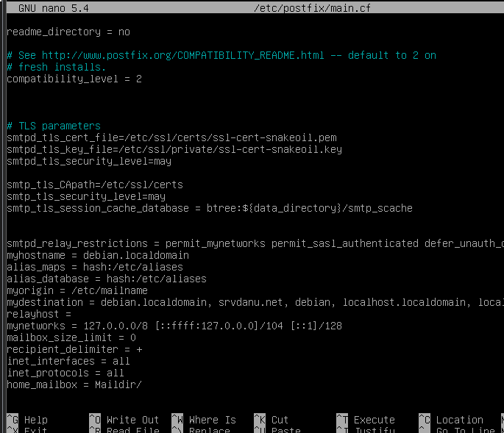
5 | Edit file dovecot.conf
6 | Edit file 10-auth.conf | 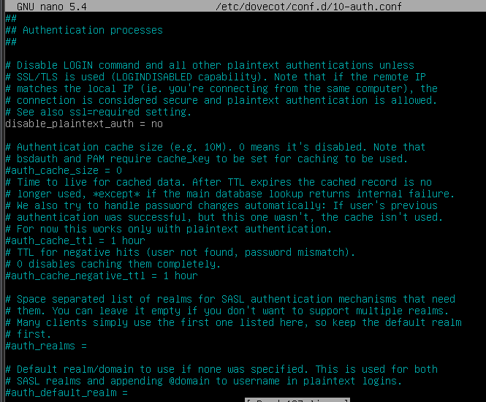
7 | Edit file 10-mail.conf | 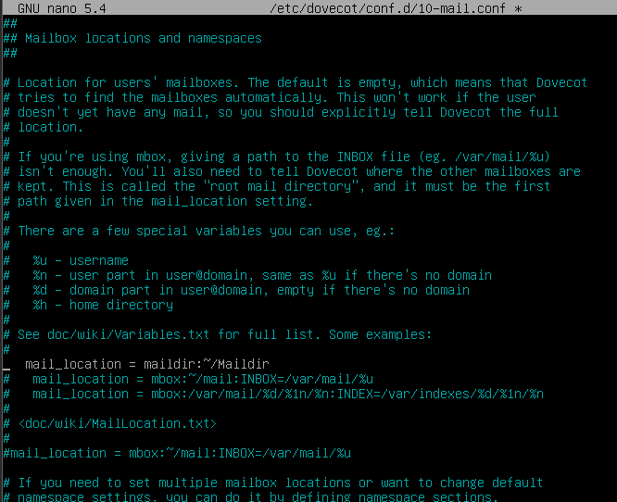
8 | Maildirmake dovecot | 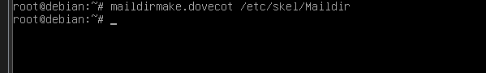
9 | Restart service postfix dan dovecot | 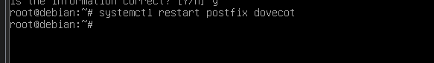
10 | Buat user1 | 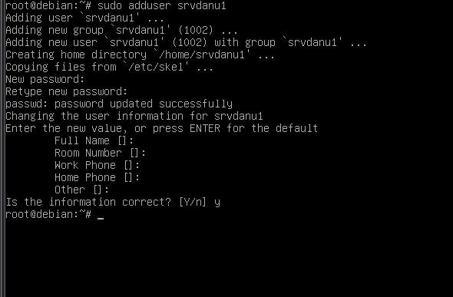
11 | Buat user2 | 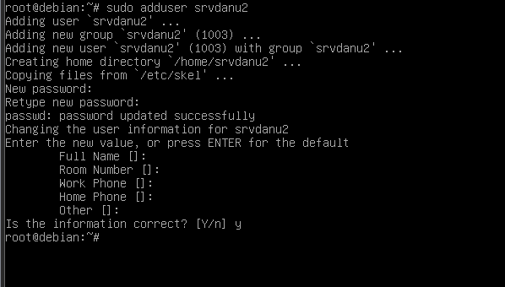
12 | Install roundcube | 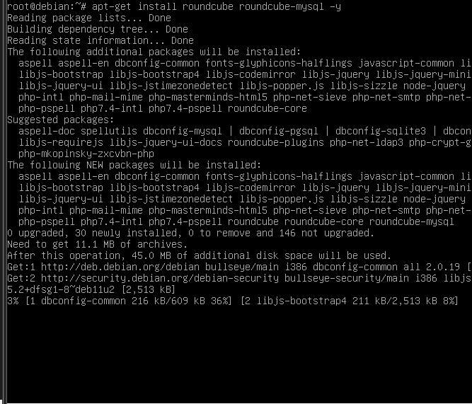
13 | Dpkg roundcube-core | 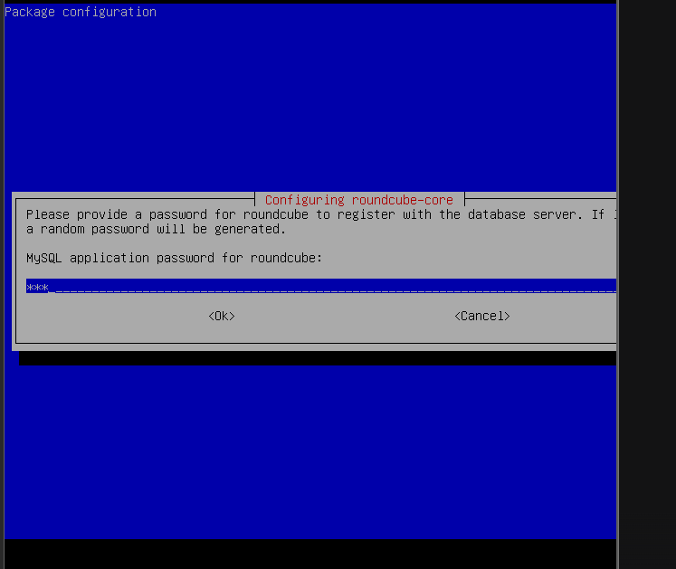
14 | Buat direktori virtualhost mail | 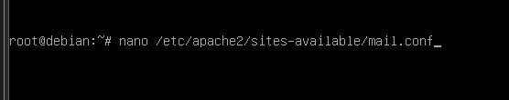
16 | Edit file mail.conf | 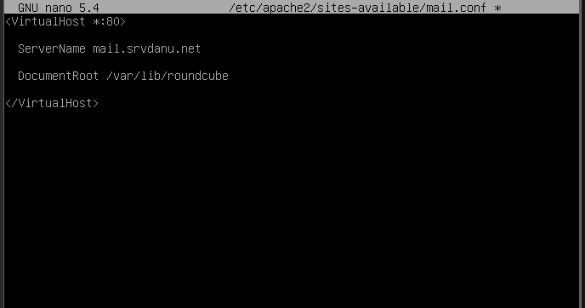
17 | Enable virtualhost mail.conf | 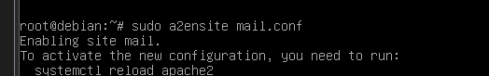
18 | Reload dan restart apache2 | 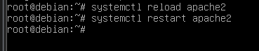

- Uji Coba
No | Uji Coba | Screenshot Hasil Ujicoba
1 | Search website subdomain mail | 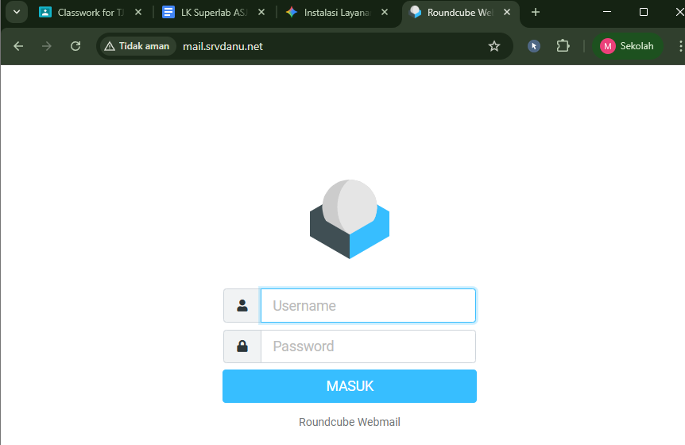
2 | Login menggunakan user 1 | 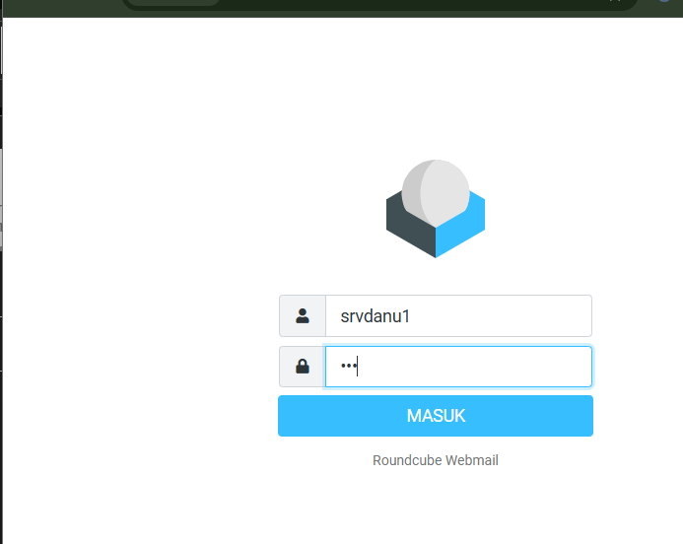
3 | User 1 mengirim email untuk user 2 | 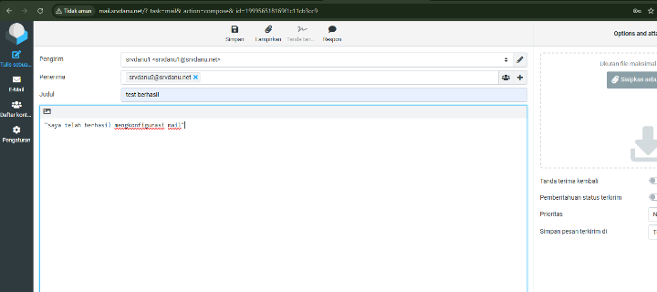
4 | Login menggunakan user 2 | 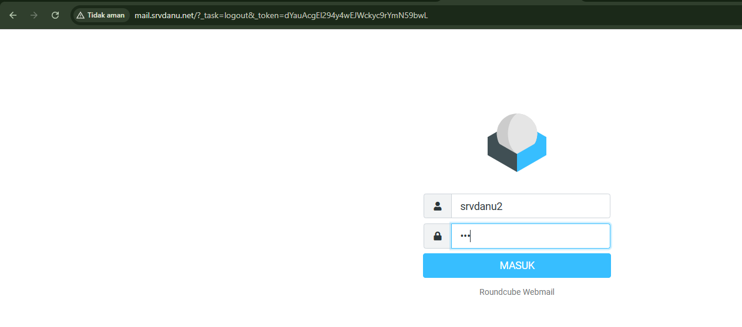
5 | Cek email dari user 1 di Inbox | 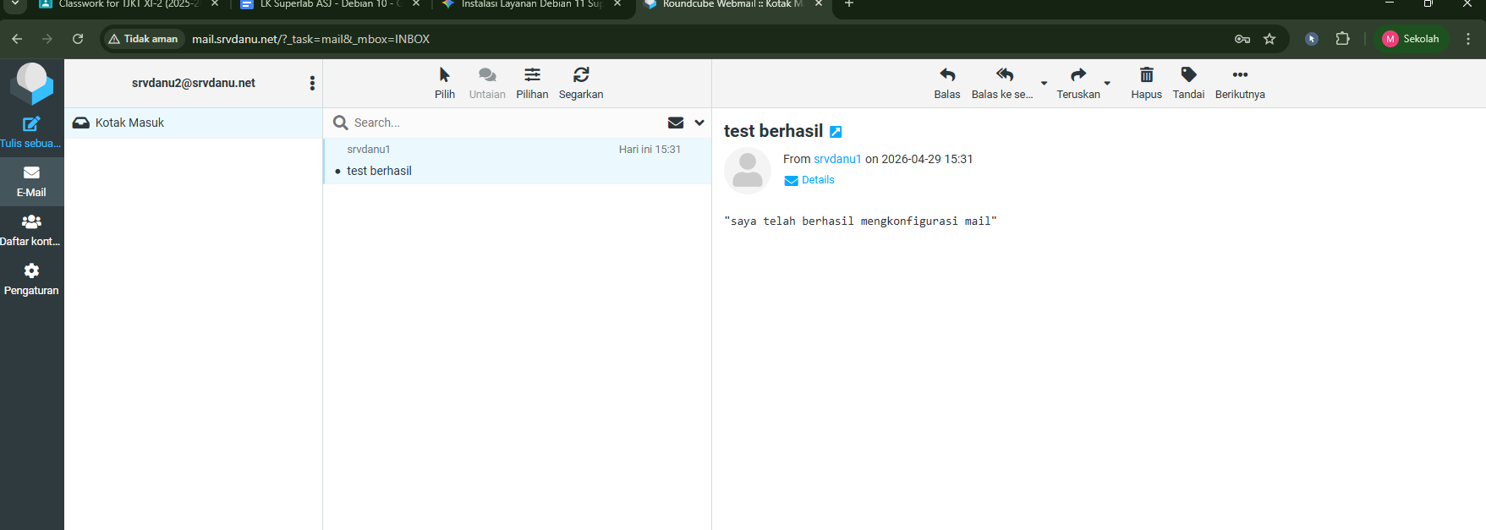
6 | Balas email dari user1 | 